**ECE 323**

**Jaime Rodriguez**

**HW#2**

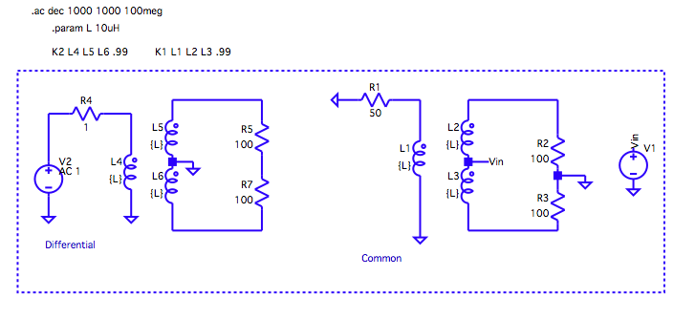

Introduction:

The purpose of this lab was to study the response of a 1: 2 trifilar wired up in two different configurations *differential* and *common* mode as seen in figure 1, both configurations were simulated in Ltspice with the transient and frequency responses analyzed. When the trifilar was set up in differential mode with the input signal going into the primary, and measuring the output across 200 ohms we see that the output signal is twice the input or 6dB. Measuring the common mode the input was moved to the center tap and the output was taken at the primary, the output was attenuated to around - 300 dB.

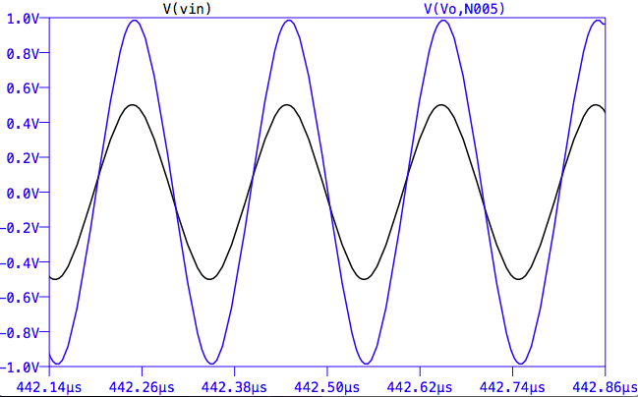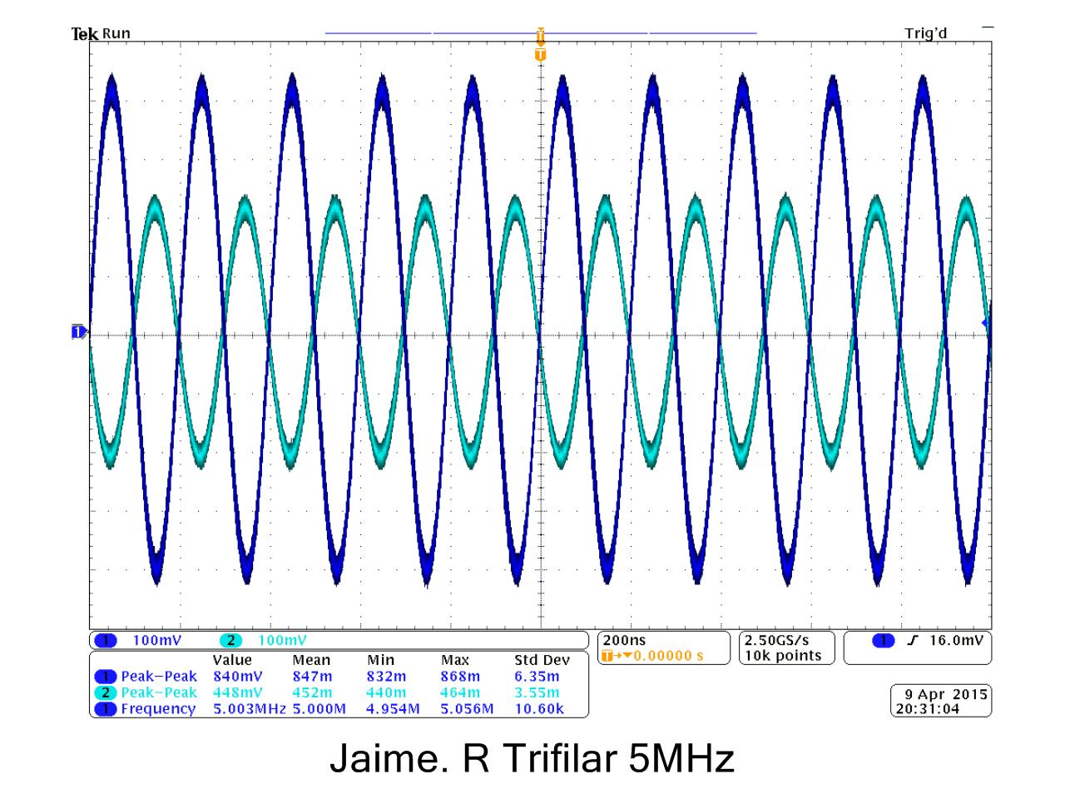

Figure , Schematic of Differential and Common mode

Next we tried to replicate these results in the lab, we wired up the trifilar using 6 turns and measured the inductance of the coils (11uH). The trifilar was wired up the same as in the schematic above for both modes with the inputs and outputs the same as in the simulation. For differential mode we can see a very similar result as in the spice, the output was a little less then twice the input, one difference that is seen is that the output signal is 180 degrees out of phase from the input.

Figure , Simulation vs. Measured

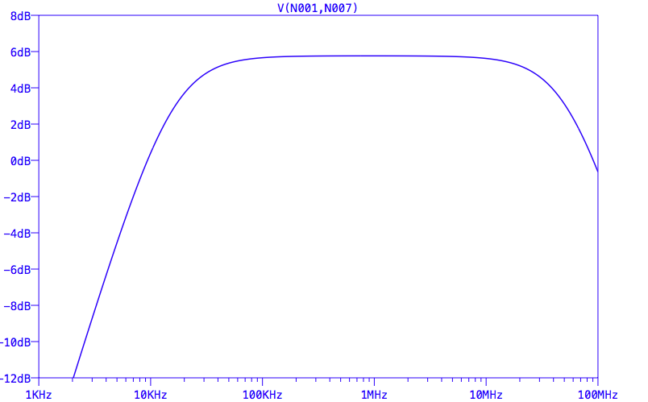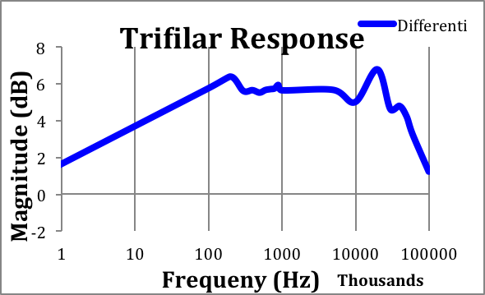

To get an idea of the frequency response of the actual trifilar, I took measurements at various frequencies from 100 to 100MHz and recorded the magnitude in dB, which I then plotted. We can see the response of the trifilar vs. the simulation; both curves have relative bandwidth with a gain of around 6dB, the actual trifilar has less of a flat response with gain closer to 5dB, I expect that this behavior is due to not having ideal transformers, I tried adding parasitic elements in the simulator to mimic the behavior but that instead added more insertion loss and distorted the cutoff curve.

When measuring the common mode configuration, the same measurement was taken at various frequencies; we can see that the magnitude of input over the output was

Figure , Differential & Common mode Response

Figure , Differential vs. Measured response.

around -26 dB, which is not as significant as in simulation but there is definite attenuation from the input signal. Overall the trifilar was not as ideal as in simulation but that is to be expected, the results still prove that the trifilar functions as expected in both configurations.